**Lab MST-1**

**Student Name: Vivek Kumar UID: 21BCS8129**

**Branch: BE-CSE(LEET) Section/Group: WM-20BCS-616/A**

**Semester: 5th Date of Performance: 30/09/2022**

**Subject Name: Project Based Learning in Java Lab Subject Code: 20CSP-321**

**1. Aim/Overview of the practical:**

WAP to implement the concept of abstraction and inheritance to print the details of stationary store.

**2. Steps for experiment/practical/Code:**

package mst;

import java.util.Scanner;

abstract class StationaryItem {

abstract String getName();

abstract void doCheckOut();

abstract void doReturn();

abstract boolean borrowedItem();

abstract int borrowCount();

}

class Operation extends StationaryItem{

String itemName;

boolean checkOut;

int borrowed=0;

public Operation(String itemName) {

this.itemName=itemName;

}

@Override

String getName()

{

return itemName;

}

@Override

void doCheckOut()

{

checkOut = false;

++borrowed;

}

@Override

void doReturn()

{

checkOut = true;

--borrowed;

}

@Override

boolean borrowedItem()

{

return checkOut;

}

@Override

int borrowCount() {

// TODO Auto-generated method stub

return borrowed;

}

}

class StationaryStore {

Operation store[]= new Operation[20];

static int a=0;

void addbook(String name)

{

store[a] = new Operation(name);

store[a].checkOut = false;

System.out.println("Stationary Item " +name +" added sucessfully");

a++;

}

void doCheckOut(String name)

{

for(int i=0; i<a;i++)

{

if(store[i].getName().equals(name))

{

store[i].doCheckOut();

System.out.println("Stationary Item " +name +" checked out successfully from "+i +" location");

}else {

System.out.println("No such Stationary Item exists at:" +i+" location");

}

}

}

void doReturn(String name)

{

for(int i= 0; i<a;i++)

{

if(store[i].getName().equals(name))

{

store[i].doReturn();

System.out.println("Stationary Item returned: " +name +" from location "+i);

}else{

System.out.println("No such Stationary Item exists at locations:" +i);

}

}

}

void listStationary()

{

for(int i= 0; i<a;i++)

{

if(!store[i].borrowedItem())

{

System.out.print("Stationary Item (location "+i+ "): "+store[i].itemName+" checked out "+store[i].borrowCount()+" times\n");

}

}

}

public void exit() {

System.exit(0);

}

}

class Main {

public static void main(String[] args) {

StationaryStore obj = new StationaryStore();

int choice;

String bookName;

boolean status = true;

while(status)

{

System.out.println("MAIN MENU");

System.out.println("*********");

System.out.println("1.Add Stationary Item:");

System.out.println("2.Check Out Stationary Item:");

System.out.println("3.Return Stationary Item:");

System.out.println("4.List Stationary Item:");

System.out.println("5.Exit");

System.out.println("Enter your choice:");

Scanner sc = new Scanner(System.in);

choice = sc.nextInt();

switch(choice)

{

case 1:

{

System.out.println("Enter the name of the Stationary Item you want to add");

bookName = sc.next();

obj.addbook(bookName);

break;

}

case 2:

{

System.out.println("Enter the name of Stationary Item to checkout");

bookName = sc.next();

obj.doCheckOut(bookName);

break;

}

case 3:

{

System.out.println("Enter the Stationary Item name to return");

bookName = sc.next();

obj.doReturn(bookName);

break;

}

case 4:

{

obj.listStationary();

break;

}

case 6:

{System.out.println("Exiting...!! Thanks for using the application");

obj.exit();

break;

}

default:

{

System.out.println("Wrong input!!");

}

}

}

}

}

**3. Result/Output:**

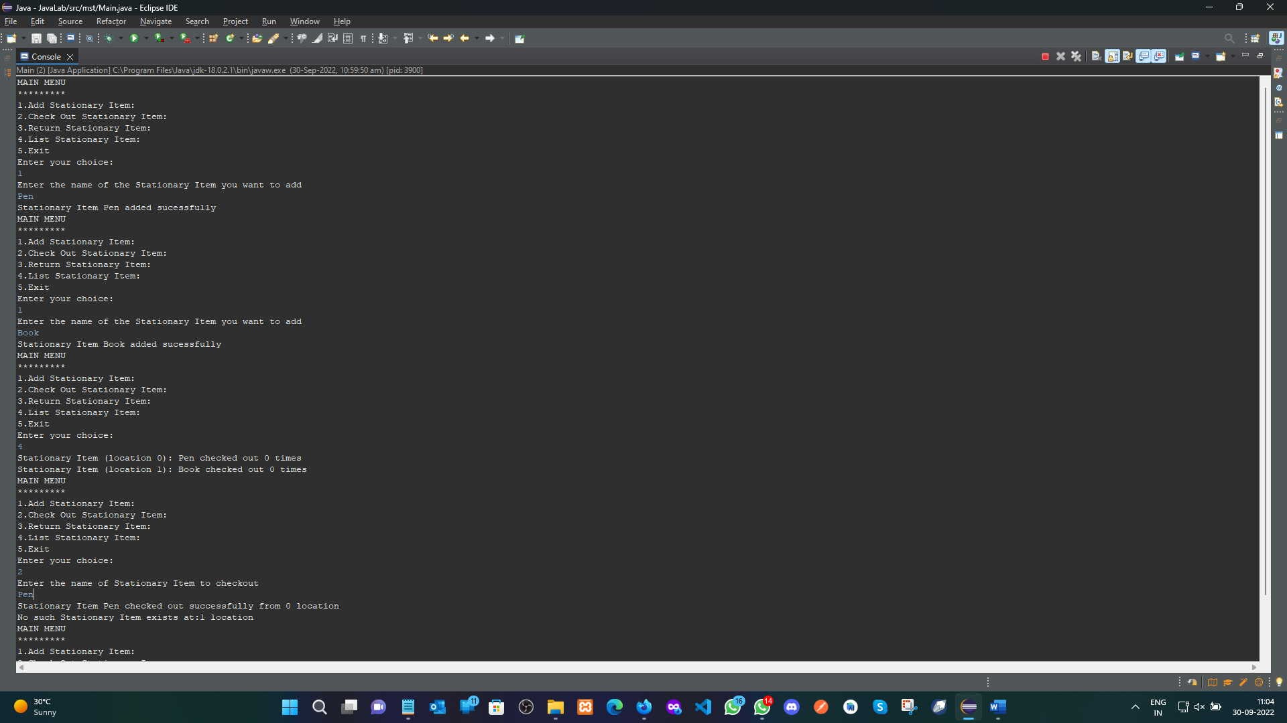

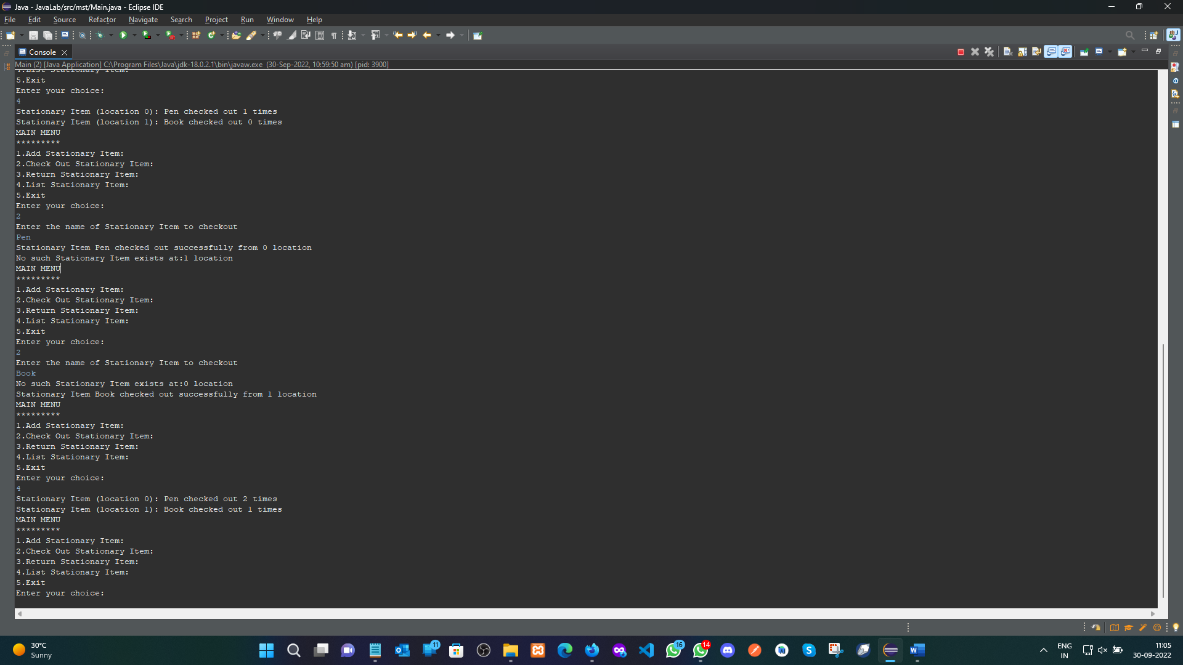

**Evaluation Grid (To be created as per the SOP and Assessment guidelines by the faculty):**

|  |  |  |  |
| --- | --- | --- | --- |
| Sr. No. | Parameters | Marks Obtained | Maximum Marks |
| 1. |  |  |  |
| 2. |  |  |  |
| 3. |  |  |  |
|  |  |  |  |